HEALTH INSURER

123 Insurance Way

Anywhere, IL 012345

DATE

RE: Claim # XXXXXXXXXXX

Insured: NAME (ID# XXXXXXXXXXX)

Claimant: NAME (DOB Mo-Day-Year)

To Whom It May Concern:

I am writing to appeal the decision to [deny coverage or apply the cost of the services to my deductible] of my bilateral-salpingo-oophorectomy by [Health Plan Name]. Genetic testing confirmed that I carry a XXXXXX genetic mutation, which puts me at significantly increased risk of ovarian cancer.

The clinical value of identifying people with an inherited mutation associated with increased risk of cancer lies in an individual’s ability to access appropriate, evidence-based screening and preventive services that lower the risk for cancer.

The National Cancer Institute indicates, “Risk-reducing salpingo-oophorectomy greatly reduces the risk of ovarian cancer and is the most effective approach.”[1] According to the American Cancer Society, “The risk of ovarian cancer is reduced by 85% to 95%, and the risk of breast cancer cut by 50% or more.”[2] in women with gene mutations who have had their ovaries removed. There is broad consensus among clinical organizations about the benefits of risk-reducing surgery in women with mutations that increase risk for ovarian cancer. The National Comprehensive Cancer Network (NCCN) [Exhibit A], American Congress of Obstetricians and Gynecologists (ACOG) [Exhibit B], and American Society of Clinical Oncology (ASCO) [Exhibit C] all recognize that preventive risk-reducing bilateral salpingo-oophorectomy is necessary for women with a genetic mutation such as mine.

According to the U.S. Centers for Disease Control and Prevention (CDC) website, “There is no reliable way to screen for ovarian cancer in women who do not have any symptoms.”[3] Most health insurers, including Aetna and Blue Cross, consider risk-reducing bilateral salpingo-oophorectomy medically necessary in high-risk women [Exhibits D and E]. Surgery is not something to be taken lightly but given my high risk of cancer and the evidence of medical necessity, my medical team and I determined that it [was/is] a needed intervention. I respectfully request that you reverse the [denial of coverage or application to my deductible] for this surgery.

Thank you for your consideration. Your prompt attention to this appeal is greatly appreciated.

Sincerely,

[Signature]

**Exhibit A**

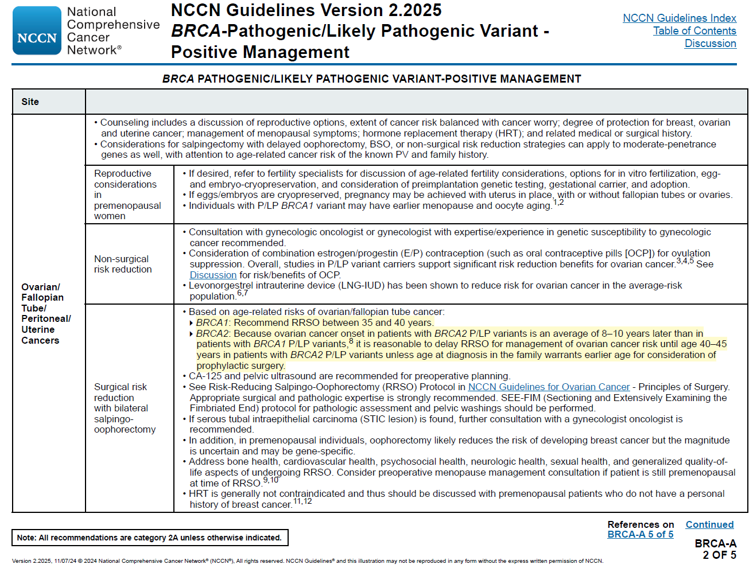

**Exhibit A (continued)**

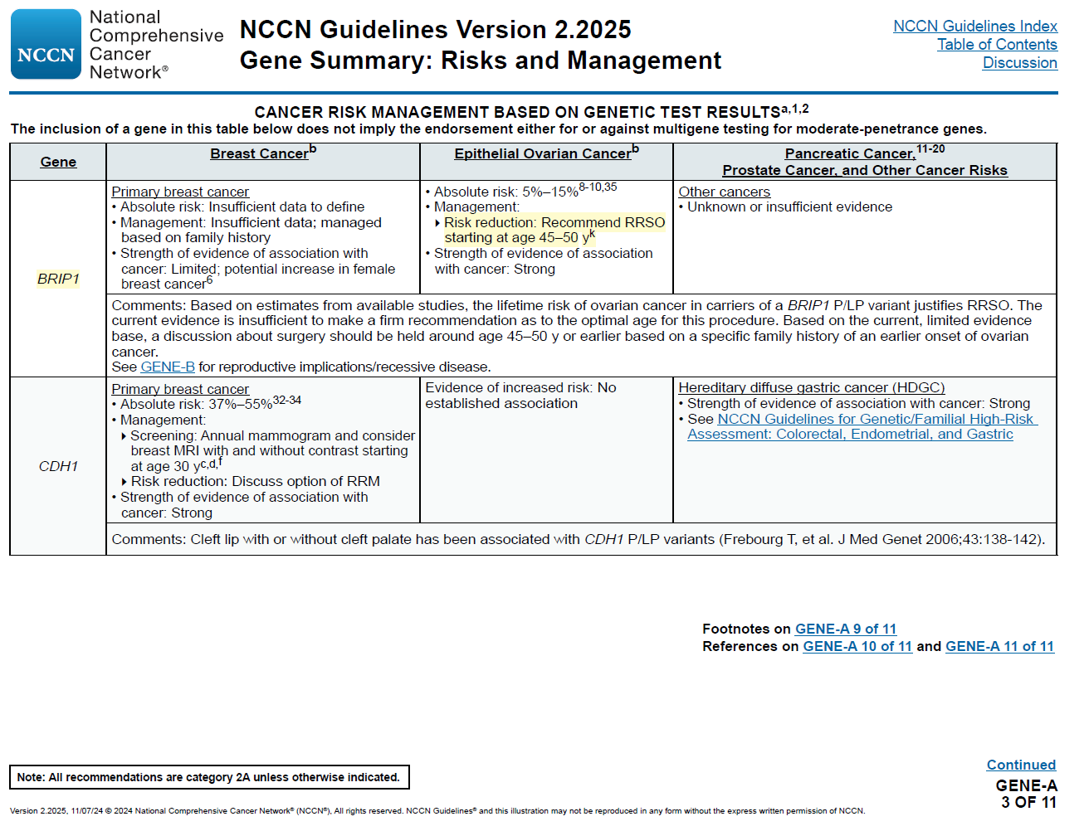

**Exhibit A (continued)**

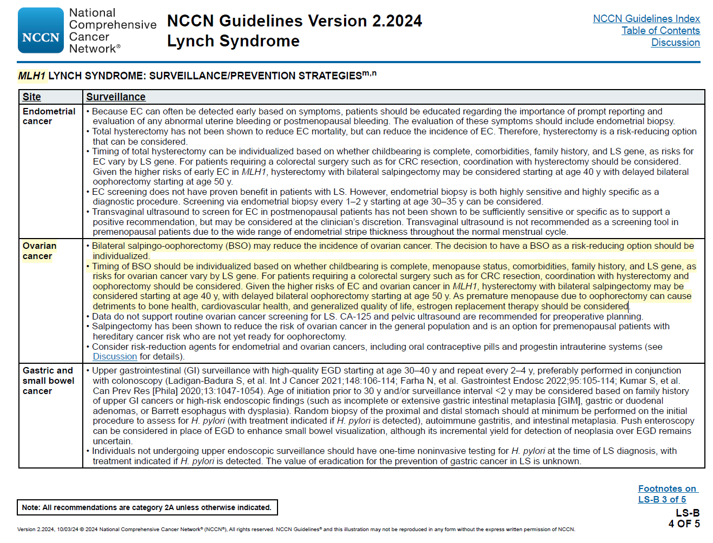

**Exhibit A (continued)**

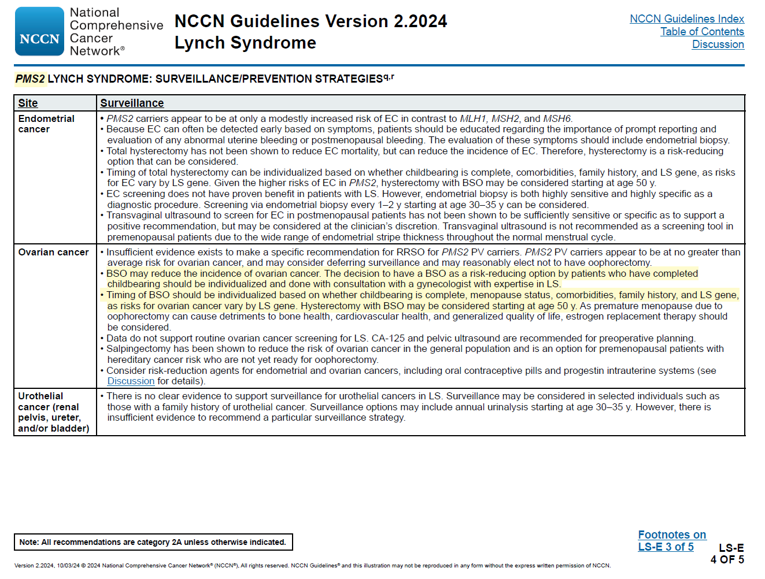

**Exhibit A (continued)**

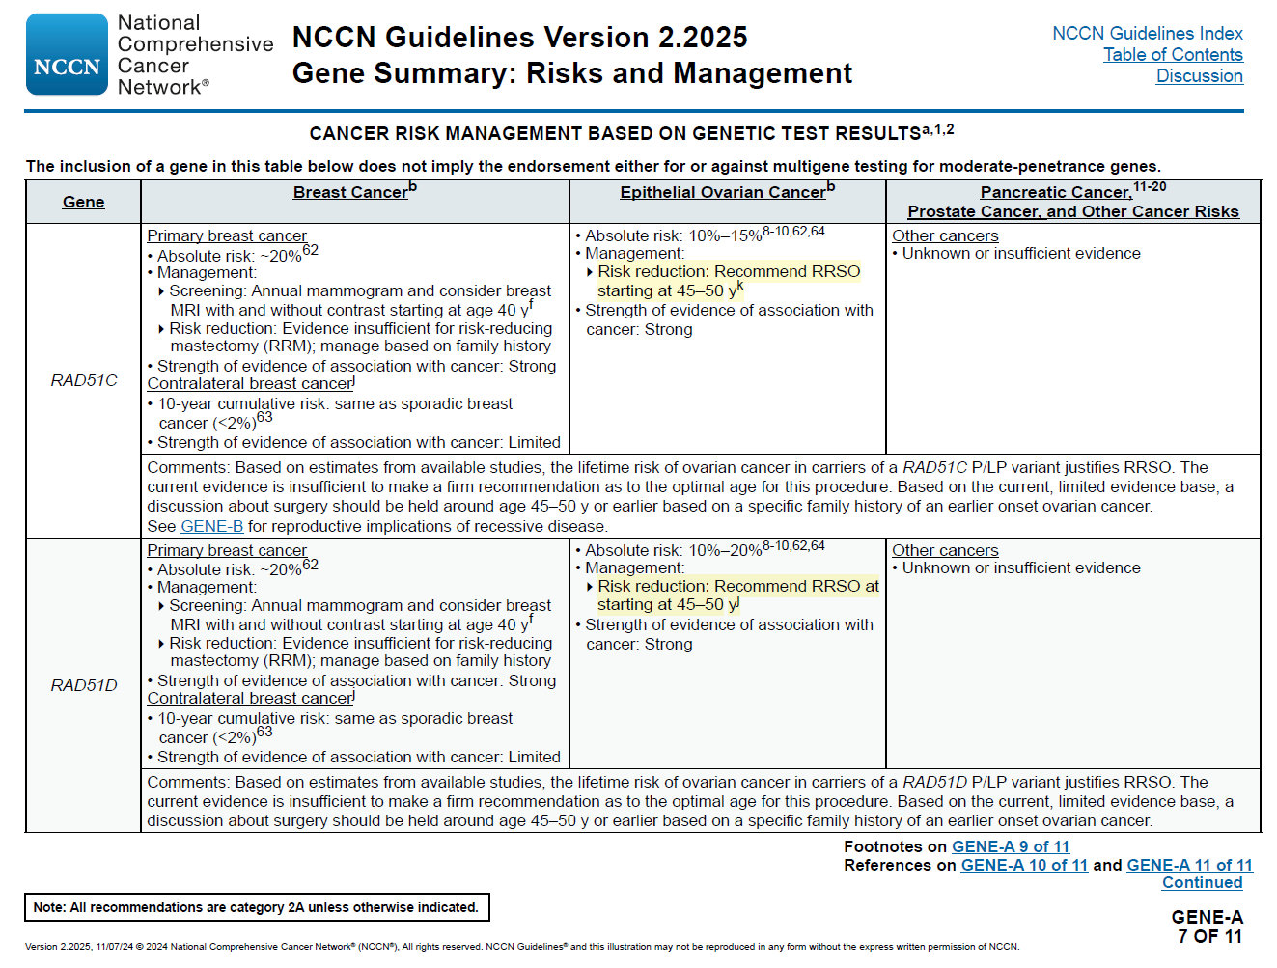

Sources:<https://www.nccn.org/professionals/physician_gls/pdf/genetics_bopp.pdf>

<https://www.nccn.org/professionals/physician_gls/pdf/genetics_ceg.pdf>

**Exhibit B**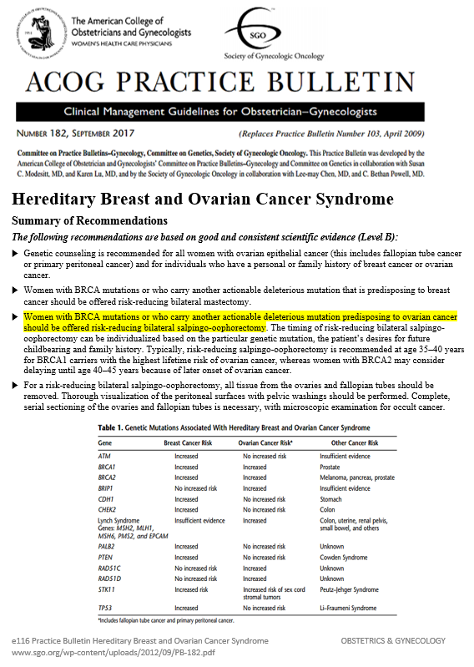

**Exhibit C**

Source: <https://ascopubs.org/doi/full/10.1200/OP.21.00382>

**Risk-Reducing Bilateral Salpingo-Oophorectomy for Ovarian Cancer: A Review and Clinical Guide for Hereditary Predisposition Genes**

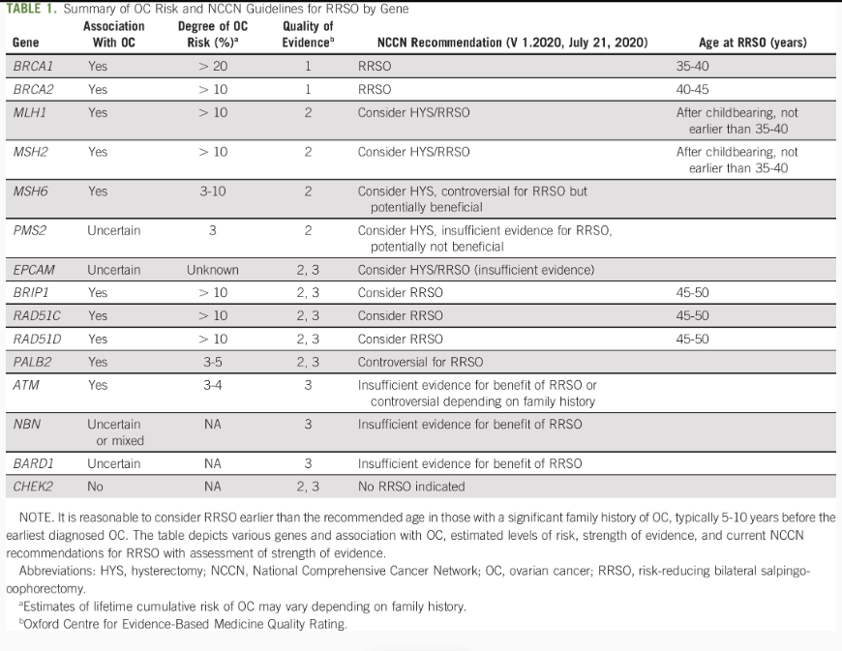

**Exhibit D**

**Exhibit E**

Source: https://medpolicy.ibx.com/ibc/Commercial/Pages/Policy/406c132a-d5dd-4514-9fdb-d5aea3517ba9.aspx

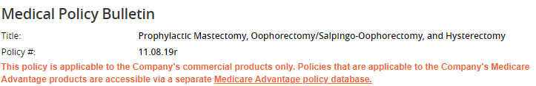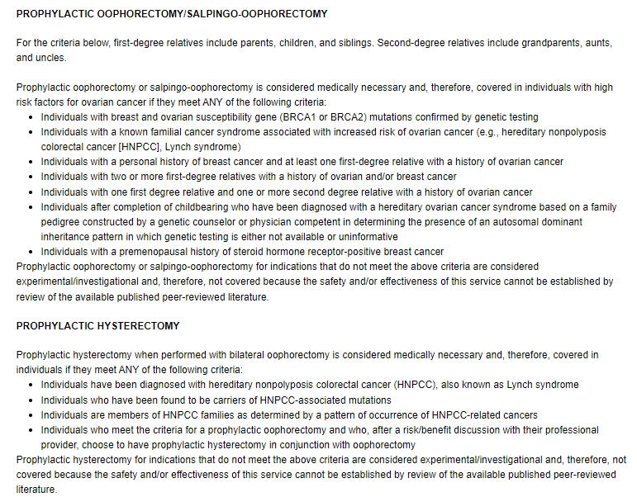

**Policy**

1. National Cancer Institute https://www.cancer.gov/types/breast/risk-reducing-surgery-fact-sheet
2. American Cancer Society https://www.cancer.org/cancer/types/ovarian-cancer/causes-risks-prevention/prevention.html
3. U.S. Centers for Disease Control and Prevention https://www.cdc.gov/ovarian-cancer/screening/index.html#:~:text=There%20is%20no%20reliable%20way,do%20to%20reduce%20your%20risk