HEALTH INSURER

123 Insurance Way

Anywhere, IL 012345

DATE

RE: Claim # XXXXXXXXXXX

Insured: NAME (ID# XXXXXXXXXXX)

Claimant: NAME (DOB Mo-Day-Year)

To Whom It May Concern:

I am writing to appeal the decision to deny coverage of my pancreatic cancer screening by [Health Plan Name]. Genetic testing confirmed that I carry a [EPCAM, MLH1, MSH2, MSH6, PALB2, TP53] genetic mutation which puts me at increased risk of pancreatic cancer. The risk of pancreatic cancer is 1.5% in the general population. Mutation carriers like me face a lifetime risk of about 5%. This risk is higher in mutation carriers with a family history of cancer[1].

Pancreatic cancer is an aggressive disease, most pancreatic cancers are diagnosed at an advanced stage, when 5-year survival is poor, as low as 13%[2]. Among all the cancers, pancreatic cancer has a disproportionately high mortality rate. When pancreatic cancer is diagnosed early, patients are more likely to survive[3]. Pancreatic cancer screening in individuals with inherited cancer risk increases the chances of detection at stage 1, the most treatable stage[4]. Early detection in individuals with an inherited mutation also may have therapeutic benefit, as tumors containing some mutations can be targeted with new drugs such as PARP or immune checkpoint inhibitors.

# The National Comprehensive Cancer Network (NCCN) recommends “annual contrast-enhanced MRI/MRCP and or EUS, with consideration of shorter screening intervals for individuals found to have worrisome abnormalities on screening.” For people with a [EPCAM, MLH1, MSH2, MSH6, PALB2, TP53] mutation and family history, the guidelines recommend beginning screening at age 50 or 10 years younger than the earliest case of pancreatic cancer in the family. [Exhibit A][5]. In 2018, the International Cancer of the Pancreas Screening (CAPS) Consortium updated its guidelines, indicating that “pancreatic surveillance is recommended for selected high-risk individuals to detect early pancreatic cancer and its high-grade precursors…”[6] [Exhibit B]

While the U.S. Preventive Services Task Force does not recommend pancreatic cancer screening for the average-risk population, it notes that the recommendation does not apply to high-risk populations   
(i.e., “Persons with certain inherited genetic syndromes or a history of familial pancreatic cancer”).[7] [Exhibit C] Many health insurers consider pancreatic cancer screening medically necessary for individuals at increased risk of this deadly disease. Given my significantly increased risk for pancreatic cancer, and the poor prognosis if the disease is not diagnosed at an early stage, my medical team and I respectfully request that you cover this crucial screening.

Thank you for your consideration. Your prompt attention to this appeal is greatly appreciated.

Sincerely,

[Signature]

**Exhibit A: NCCN Guidelines for Pancreatic Cancer Screening in People with Inherited Mutations**

**Exhibit B: CAPS Consortium Recommendations**

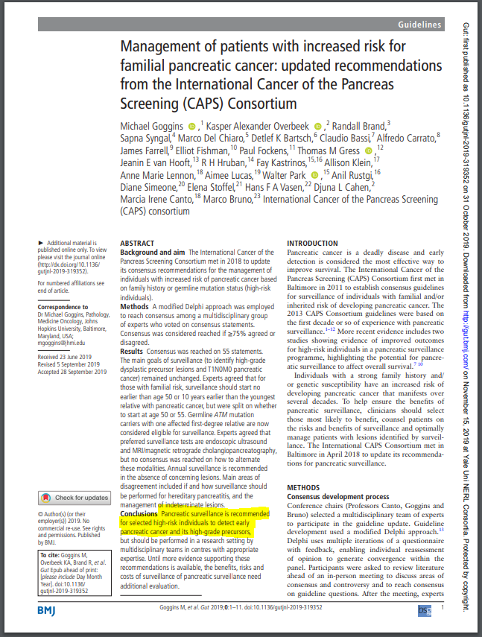

**Exhibit C: USPSTF Pancreatic Cancer Screening Guidelines for Average Risk People**

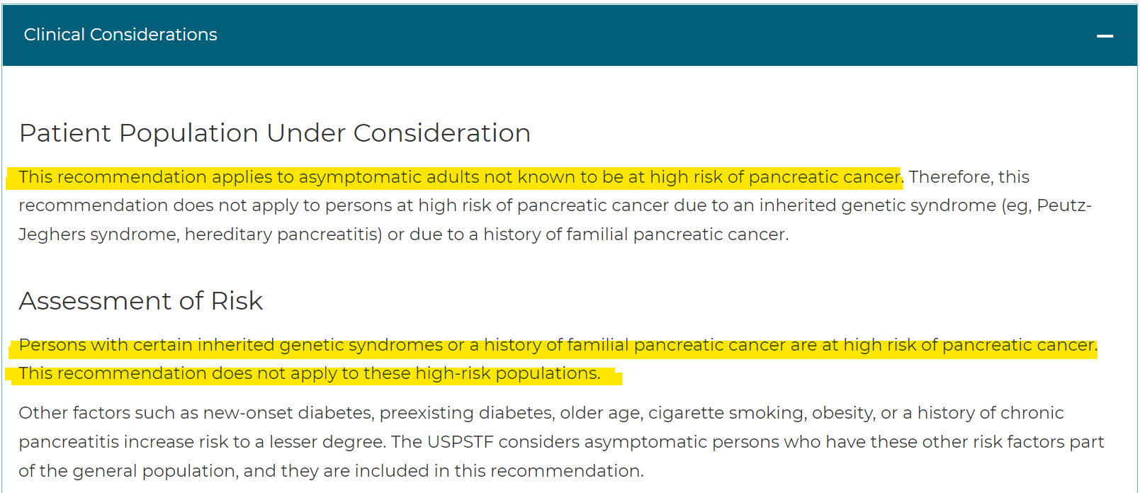

1. NCCN Guidelines: Genetic/Familial High-Risk Assessment: Breast, Ovarian, Pancreatic, Prostate vs. 2 2025.
2. SEER*Explorer: An interactive website for SEER cancer statistics [Internet]. Surveillance Research Program, National Cancer Institute; 2024 Apr 17. [updated: 2024 Nov 5; cited 2025 Jan 19]. Available from: https://seer.cancer.gov/statistics-network/explorer/. Data source(s): SEER Incidence Data, November 2023 Submission (1975-2021), SEER 22 registries. Retrieved from database January 2025.
3. Ibid
4. Blackford AL, Canto MI, Dbouk M, et al. Pancreatic Cancer Surveillance and Survival of High-Risk Individuals. *JAMA Oncol.* 2024;10(8):1087–1096. doi:10.1001/jamaoncol.2024.1930
5. NCCN Guidelines: Genetic/Familial High-Risk Assessment: Breast, Ovarian, Pancreatic, Prostate vs. 2 2025.
6. Gut. 2020 Jan;69(1):7-17. doi: 10.1136/gutjnl-2019-319352. Epub 2019 Oct 31. (https://gut.bmj.com/content/69/1/7.long)
7. U.S. Preventive Services Task FORCE Final Recommendation Statement, Pancreatic Cancer: Screening (www.uspreventiveservicestaskforce.org/Page/Document/RecommendationStatementFinal/pancreatic-cancer-screening)