HEALTH INSURER

123 Insurance Way

Anywhere, IL 012345

DATE

RE: Claim # XXXXXXXXXXX

Claimant: NAME (ID# and DOB: Mo-Day-Year)

To Whom It May Concern:

I am writing to appeal [Health Plan Name]’s decision to [deny coverage or apply the cost of the services to my deductible] of my colonoscopy, which took place on [date] at [facility]. It is my understanding that [Health Plan Name] covers medically necessary services that are not expressly excluded. [Attach or reference relevant section(s) from health insurer’s Policy or Evidence of Coverage, if possible.]

I have a Lynch syndrome genetic mutation, which places me in the high-risk category for colorectal cancer. Per the Centers for Disease Control (CDC), “Lynch syndrome (LS) is an inherited predisposition to colorectal cancer (CRC), responsible for 3-5% of all CRC. This syndrome is characterized by the early occurrence of colorectal [cancer] ... colorectal screening by colonoscopy is efficient because it is associated with a reduction >50% of both CRC incidence and CRC related mortality.”[1]

The U.S. Preventive Services Task Force (USPSTF) Colorectal Cancer Screening guidelines state, “This recommendation applies to asymptomatic adults 45 years or older who are at average risk of colorectal cancer (i.e., no prior diagnosis of colorectal cancer, adenomatous polyps, or inflammatory bowel disease; no personal diagnosis or family history of known genetic disorders that predispose them to a high lifetime risk of colorectal cancer [such as Lynch syndrome or familial adenomatous polyposis])” The guidelines go on to note, “Persons who have hereditary cancer syndromes such as Lynch syndrome are at very high risk for colorectal cancer and may need screening strategies that go beyond the evidence that the USPSTF reviewed.”[2]

There is broad consensus about the medical necessity of earlier, more frequent colorectal cancer screening for those at increased risk. The National Cancer Institute provides a table of Lynch Syndrome CRC screening practice guidelines for health care professionals, all of which indicate that colonoscopies should start between ages 20-35 or earlier based on family history [Exhibit A].

The National Comprehensive Cancer Network (NCCN) Guidelines for Patients, Colorectal Cancer Screening outlines increased risk [Exhibit B], and outlines screening guidelines for those with Lynch Syndrome in their Clinical Practice Guidelines “Genetic/Familial High-Risk Assessment: Colorectal” [Exhibit C]. Additionally, the National Library of Medicine’s recommendation aligns with earlier screening for those at higher risk of colorectal cancer [Exhibit D].

Many health insurers, including Blue Cross Blue Shield, and Aetna cover screening colonoscopies for high-risk individuals at younger ages than for average-risk individuals [Exhibits E and F]. Given my high risk of CRC, I respectfully request that you cover my colonoscopies. The guidelines make it clear that this is a medically necessary intervention for people with Lynch syndrome, such as me.

Thank you for your consideration. Your prompt attention to this matter is greatly appreciated.

Sincerely,

[Signature]

**Exhibit A**

Genetics of Colorectal Cancer (PDQ®)–Health Professional Version

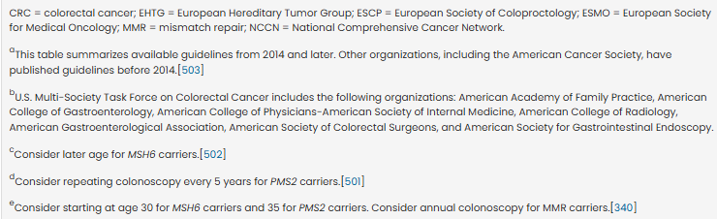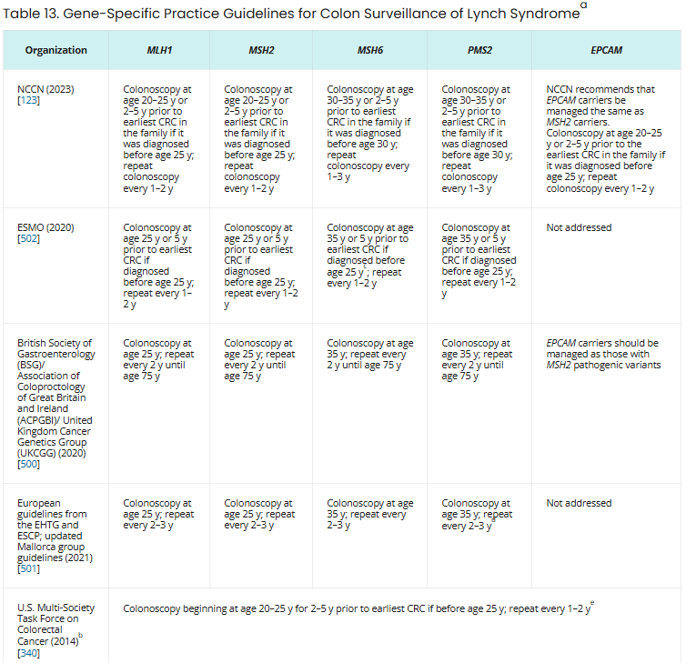

Source: Source: https://www.cancer.gov/types/colorectal/hp/colorectal-genetics-pdq

**Exhibit B**

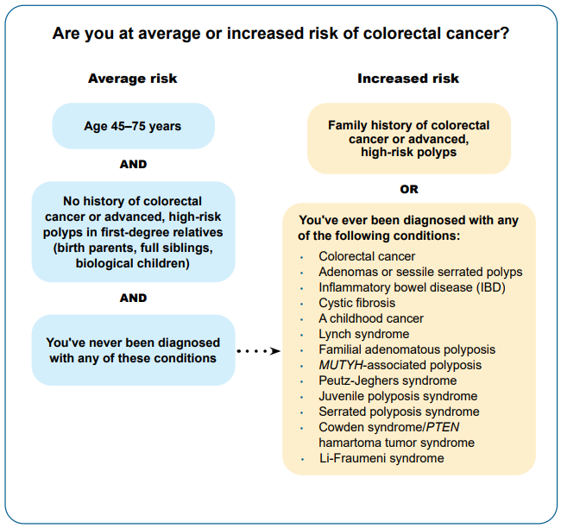

Source: https://www.nccn.org/patients/guidelines/content/PDF/colorectal-screening-patient.pdf

**Exhibit C**

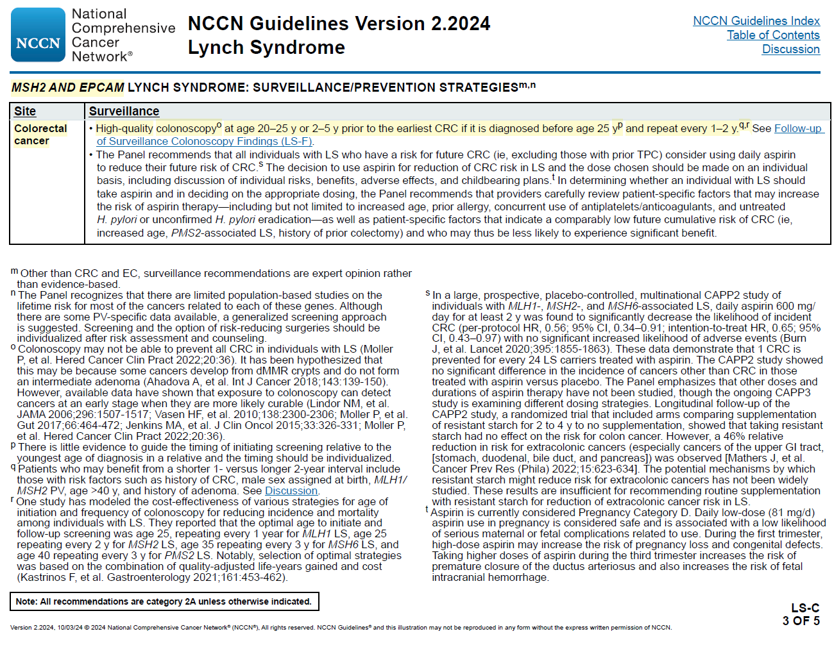**Exhibit C (continued)**

**Exhibit C (continued)**

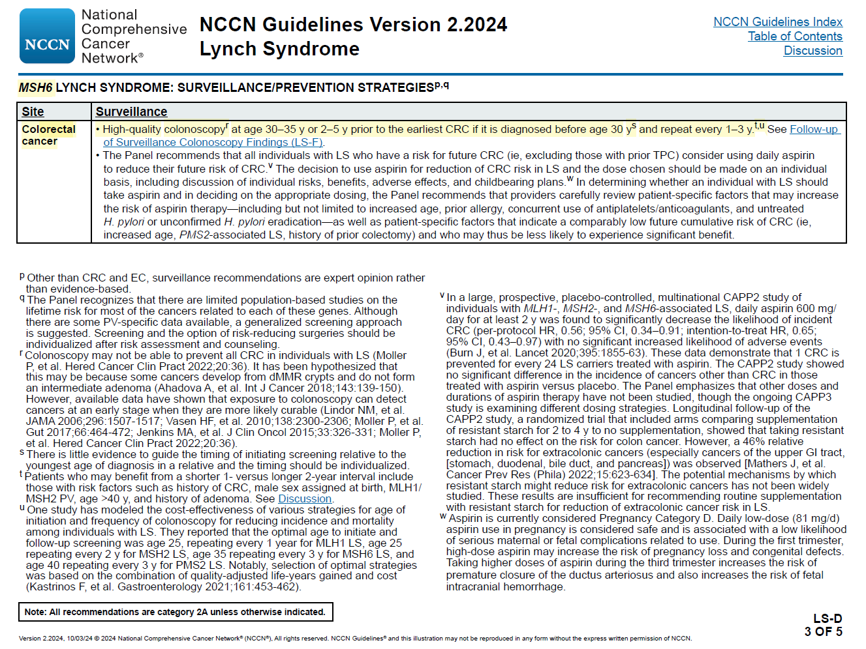

**Exhibit C (continued)**

Source: <https://www.nccn.org/professionals/physician_gls/pdf/genetics_ceg.pdf>

**Exhibit D**

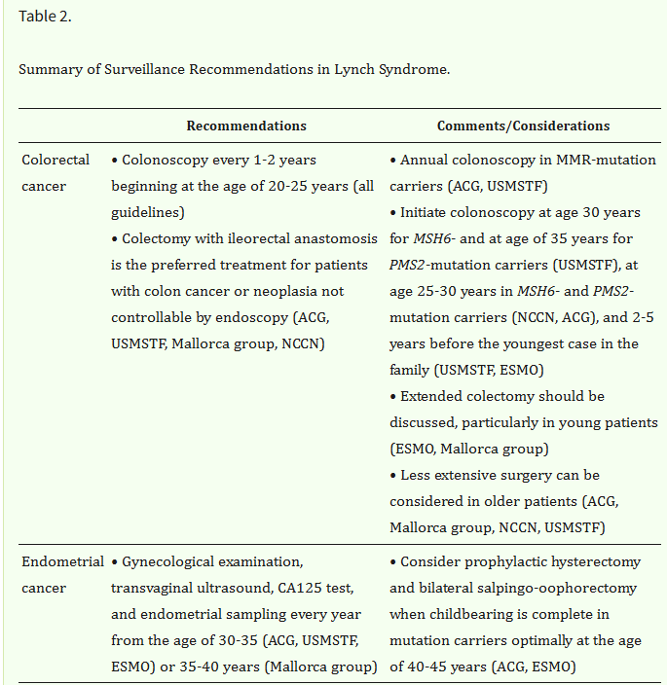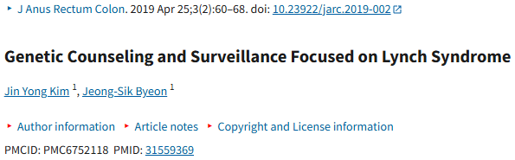

**Exhibit D (continued)**

is the only surveillance protocol demonstrated to be effective.

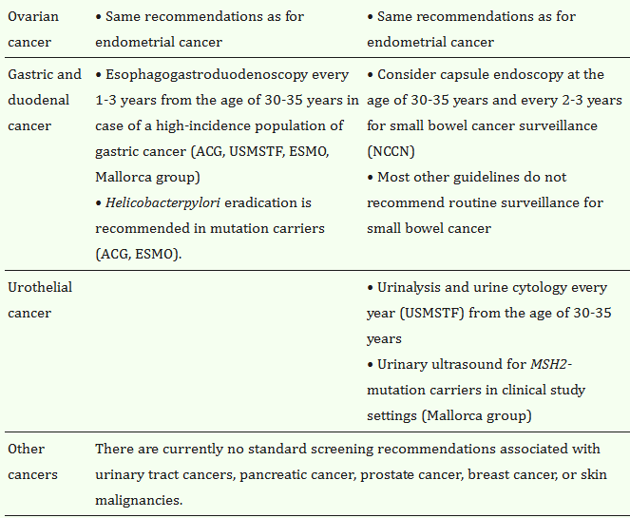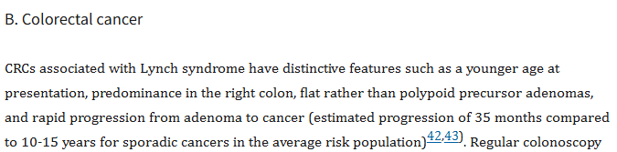

Source: https://pmc.ncbi.nlm.nih.gov/articles/PMC6752118/

**Exhibit E**

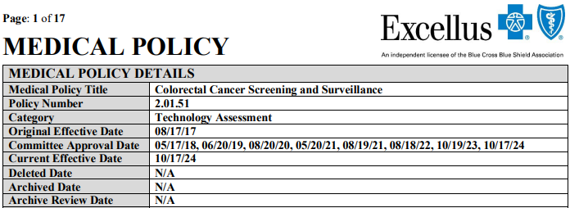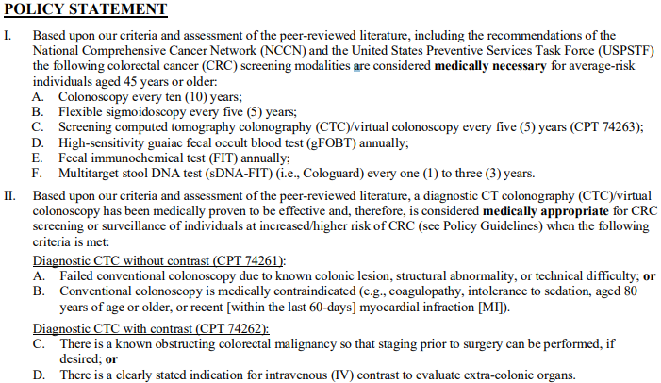

**POLICY GUIDELINES**

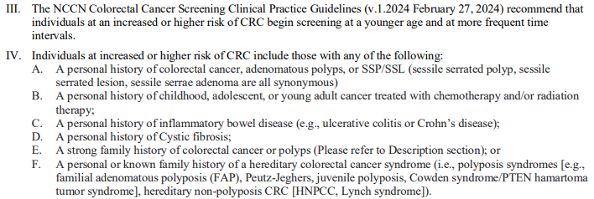

Source: https://provider.excellusbcbs.com/documents/d/global/exc-prv-colorectal-cancer-screening-and-surveillance

**Exhibit F**

FOBT= fecal occult blood testing

**Colonoscopy and Colorectal Cancer Screening**

Clinical Policy Bulletins | Medical Clinical Policy Bulletins

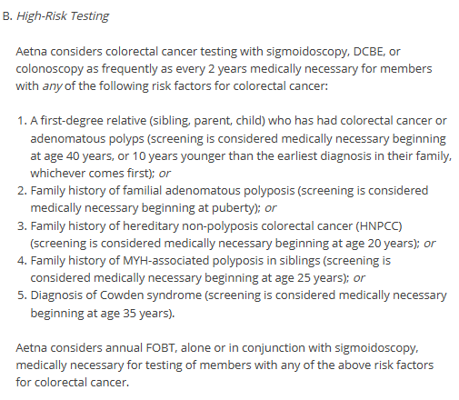

Source: https://www.aetna.com/cpb/medical/data/500_599/0516.html

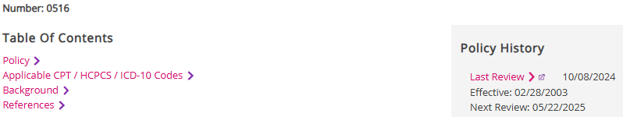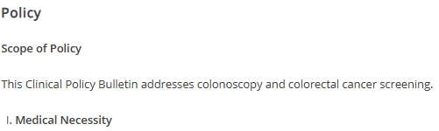

1. NIH National Library of Medicine, Colorectal cancer screening in Lynch syndrome: Indication, techniques and future perspectives https://pubmed.ncbi.nlm.nih.gov/32314431/

  
2. U.S. Preventive Services Task Force Final Recommendation Statement, Colorectal Cancer: Screening - www.uspreventiveservicestaskforce.org/uspstf/recommendation/colorectal-cancer-screening#fullrecommendationstart