Health Insurer

123 Insurance Way

Anywhere, IL 012345

DATE

RE: Claim # XXXXXXXXXXX

Insured: NAME (ID# XXXXXXXXXXX)

Claimant: NAME (DOB Mo-Day-Year)

To Whom It May Concern:

I am writing to appeal the decision to deny coverage of my prophylactic bilateral mastectomy by [Health Plan Name]. I have a significant family history of early onset, aggressive breast and other cancers. Accordingly, I have been advised to undergo increased screening for breast cancer. Due to my strong family history of cancer, I had genetic testing to determine if I carry an inherited genetic mutation associated with an increased risk of cancer. I would like to note that [Health Plan Name]paid for this testing. While no known mutation was found, [Risk Assessment Tool] indicates that my risk of breast cancer is XX%.[1] To put this in perspective, the average woman has a 13% risk of breast cancer in her lifetime.

While genetic testing was not able to identify a specific gene mutation responsible for the cancers in my family, my breast cancer risk is comparable to that of a woman with a genetic mutation. Most experts agree that women with a lifetime risk of breast cancer exceeding 20% are considered “high risk.”

It is also important to note that ACOG *Hereditary Cancer Syndromes and Risk Assessment* explains that “… the results of genetic tests may be challenging to interpret without expert guidance. A positive result does not equate with a clinical diagnosis, and a negative result is not indicative of the absence of disease risk …. The context of type of test performed, and other health factors including family history must be considered.”[2]

The National Cancer Institute says, “Bilateral mastectomy has been shown to reduce the risk of breast cancer by at least 95% in women who have a harmful (disease-causing) variant in the BRCA1 gene or the BRCA2 gene and up to 90% in women who have a strong family history of breast cancer.”[3] The USPSTF and Journal of the American Medical Association (JAMA) reference studies of high-risk women and women with genetic mutations stating that a risk-reducing ‘Bilateral mastectomy was associated with a 90% to 100% reduced breast cancer incidence.”4 There is broad consensus among clinical organizations about the benefits of risk-reducing surgery in high-risk women.

The National Cancer Institute [Exhibit A], and others recommend the option of bilateral prophylactic mastectomy, also known as a risk-reducing mastectomy (RRM), for women with certain genetic mutations and those over the 20% breast cancer risk threshold.

The vast majority of health insurers, including Aetna and BlueCross BlueShield, consider prophylactic mastectomy “medically necessary” for the reduction of breast cancer risk in certain women [Exhibit B and C]. I meet the clinical standards outlined in these policies, including family history of early-onset breast cancer and dense breasts.

No woman wants to undergo a mastectomy but given the exceptional risk of cancer, women like me are faced with a difficult choice—live in constant fear with the threat of aggressive and sometimes fatal disease or opt for surgery to help maintain their health.

Given my significant breast cancer risk, this surgery meets the criteria for medical necessity. With the evidence provided herein, I respectfully request that you allow me to be proactive with my health. Ultimately, the cost of risk-reducing mastectomy with reconstruction is far less expensive than a breast cancer diagnosis—which would involve not only surgery and reconstruction, but chemotherapy, radiation, extensive time out of work, etc.

Thank you for your consideration. Your prompt attention to this appeal is greatly appreciated.

Sincerely,

[Signature]

**Exhibit A**



**Surgery to Reduce the Risk of Breast Cancer**

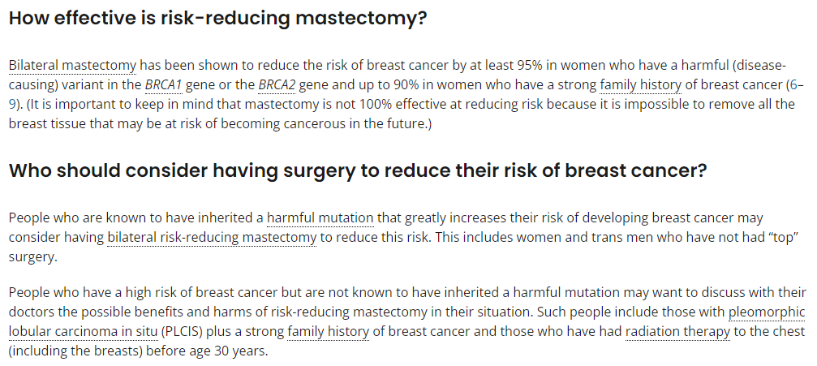

Source: https://www.cancer.gov/types/breast/risk-reducing-surgery-fact-sheet

**Exhibit B**

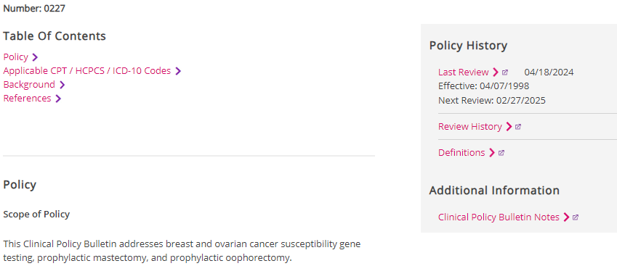

Breast and Ovarian Cancer Susceptibility Gene Testing, Prophylactic Mastectomy, and Prophylactic Oophorectomy



Source: <https://www.aetna.com/cpb/medical/data/200_299/0227.html>

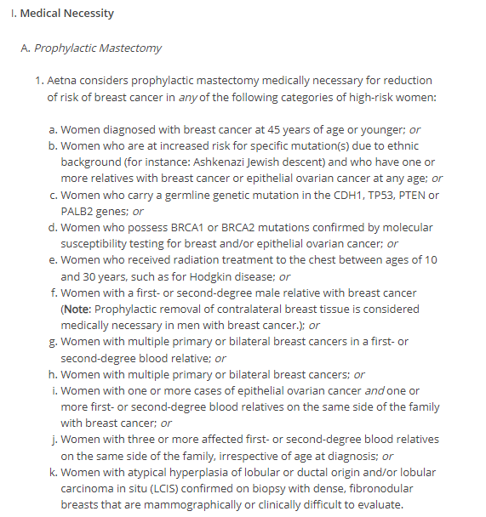

**Exhibit C**

**Prophylactic Mastectomy**

Source: https://www.bcbsnd.com/providers/policies-precertification/medical-policy/p/prophylactic-mastectomy

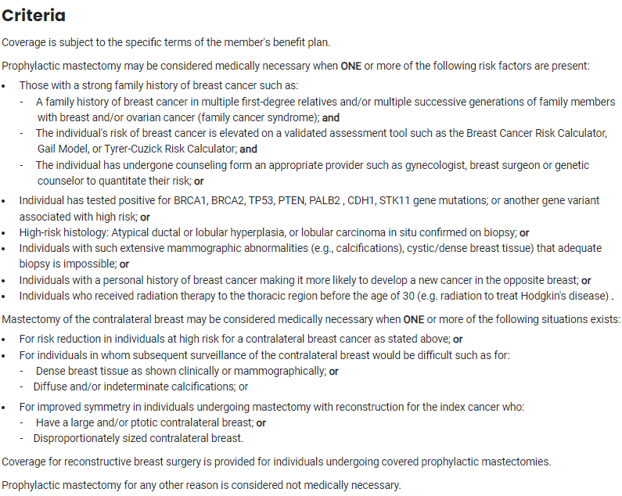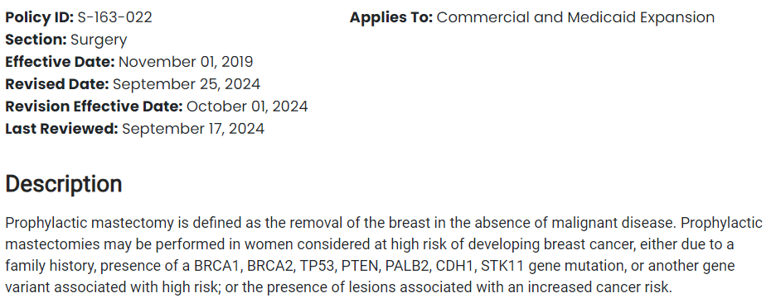

1. Estimate calculated using the [Risk Assessment Tool]. This is a well-studied, evidence-based model for predicting breast cancer risk. 
2. ACOG Hereditary Cancer Syndromes and Risk Assessment December 2019 (https://www.acog.org/clinical/clinical-guidance/committee-opinion/articles/2019/12/hereditary-cancer-syndromes-and-risk-assessment)
3. # Surgery to Reduce the Risk of Breast Cancer ([www.cancer.gov/types/breast/risk-reducing-surgery-fact-sheet](http://www.cancer.gov/types/breast/risk-reducing-surgery-fact-sheet))

   4Risk Assessment, Genetic Counseling, and Genetic Testing for BRCA-Related Cancer (https://jamanetwork.com/journals/jama/fullarticle/2748515)