HEALTH INSURER

123 Insurance Way

Anywhere, IL 012345

DATE

RE: Claim # XXXXXXXXXXX

Insured: NAME (ID# XXXXXXXXXXX)

Claimant: NAME (DOB Mo-Day-Year)

To Whom It May Concern:

I am writing to appeal [Health Plan Name]’s decision to deny coverage of my mammogram, which took place on [date] at [radiology facility]. It is my understanding that [Health Plan Name] covers medically necessary services that are not expressly excluded. [Attach or reference relevant section(s) from health insurer’s Policy or Evidence of Coverage, if possible.]

I have a significant family history of breast cancer. [Risk Assessment Tool] indicates that my risk of breast cancer is XX%. Accordingly, I have been advised to undergo increased screening for breast cancer. To put this in perspective, the average woman has a 13% risk of breast cancer in her lifetime.

While I have had genetic testing [date of testing and result] and no known mutation was reported, my risk of breast cancer is similar to women who carry and inherited genetic mutation.

My healthcare team has indicated that an annual breast mammogram is medically necessary for risk management. There is broad consensus about the medical necessity of breast mammography for women at high risk of breast cancer. The National Comprehensive Cancer Network (NCCN) is a professional organization that develops standard-of-care consensus guidelines in cancer. NCCN Guidelines for “Breast Cancer Screening and Diagnosis” state that women with a greater or equal to a 20% increased risk mutation should begin annual screening mammography 10 years prior to when the youngest family member was diagnosed with breast cancer. [Exhibit A]

The American Congress of Obstetricians and Gynecologists (ACOG) states that women aged 30 years and older who are at increased risk of breast cancer… recommended breast cancer surveillance includes annual mammography and annual breast MRI with contrast, often alternating every 6 months.[1]

The American Cancer Society [Exhibit B], Society of Breast Imaging and American College of Radiology (ACR) [Exhibit C] recommend breast mammography screenings beginning at age 30 for women with an estimated lifetime risk of 20% or more.

Many health insurers, including Aetna and Cigna, consider screening mammography an appropriate intervention in high-risk women under the age of 40. I meet the criteria outlined in these policies [Exhibit D].

Given my family history and increased risk of breast, I respectfully request that you cover my recent mammogram. The guidelines make it clear that this service is a medically necessary intervention for women at increased risk of breast cancer such as myself.

Thank you for your consideration. Your prompt attention to this matter is greatly appreciated.

Sincerely,

[Signature]

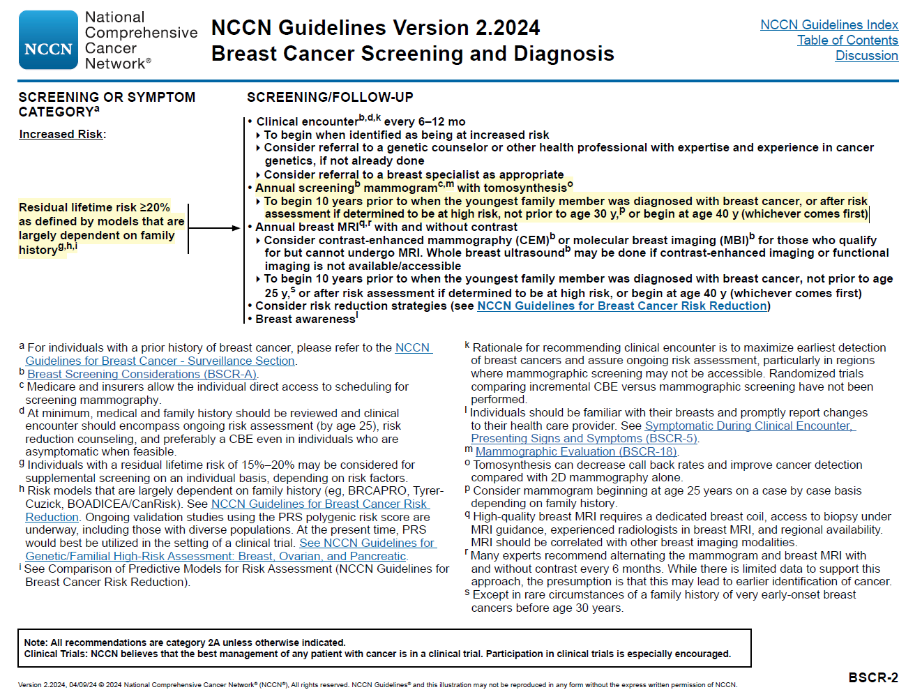**Exhibit A**

https://www.nccn.org/professionals/physician_gls/pdf/breast-screening.pdf

**Exhibit B**

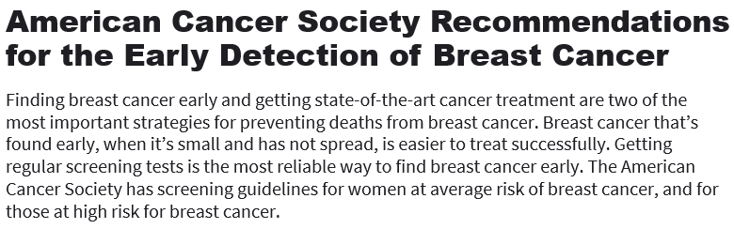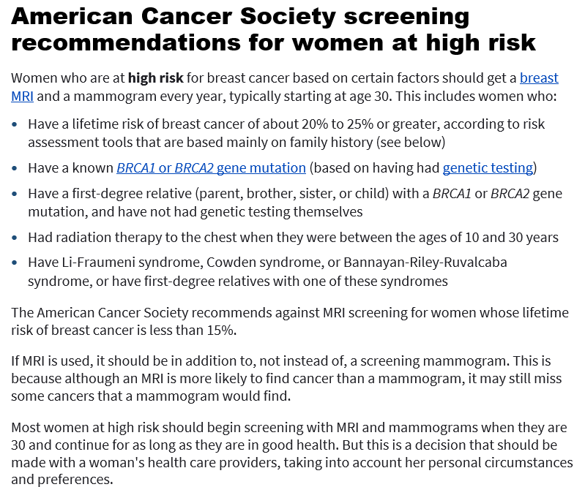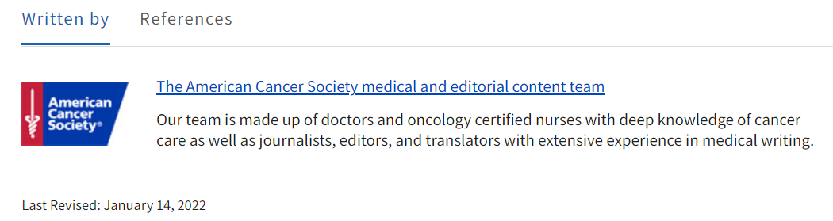

Last Revised: January 14, 2022

www.cancer.org/cancer/breast-cancer/screening-tests-and-early-detection/american-cancer-society-recommendations-for-the-early-detection-of-breast-cancer.html

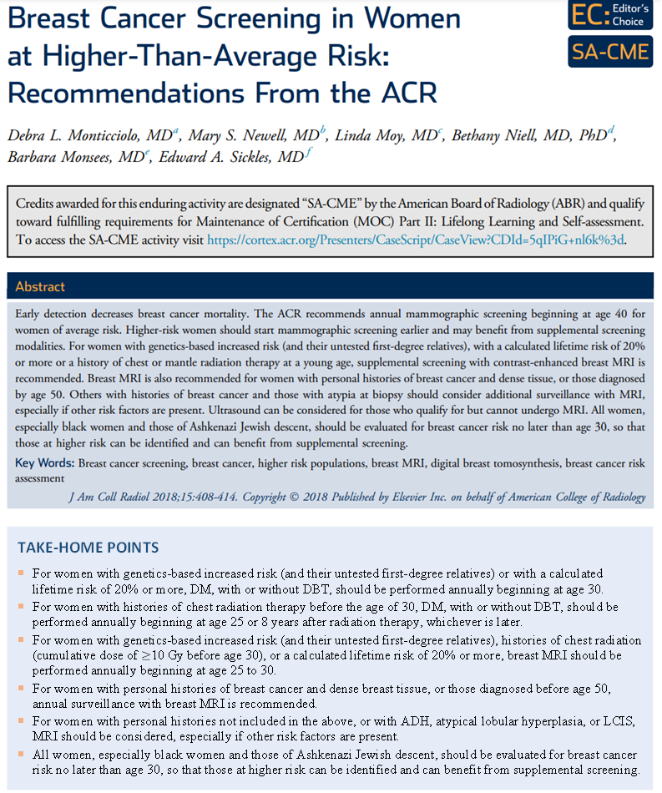**Exhibit C**

[www.jacr.org/action/showPdf?pii=S1546-1440%2817%2931524-7](http://www.jacr.org/action/showPdf?pii=S1546-1440%2817%2931524-7)

**Exhibit D**

## 

https://cignaforhcp.cigna.com/public/content/pdf/coveragePolicies/medical/mm_0123_coveragepositioncriteria_mammography.pdf

1. Practice Bulletin Hereditary Breast and Ovarian Cancer Syndrome, VOL. 130, NO. 3, SEPTEMBER 2017, pg. e117 <https://www.sgo.org/wp-content/uploads/2012/09/PB-182.pdf>