HEALTH INSURER

123 Insurance Way

Anywhere, IL 012345

DATE

RE: Claim # XXXXXXXXXXX

Insured: NAME (ID# XXXXXXXXXXX)

Claimant: NAME (DOB Mo-Day-Year)

To Whom It May Concern:

I am writing to appeal [Health Plan Name]’s decision to [deny coverage or apply the cost of the services to my deductible] of my mammogram, which took place on [date] at [radiology facility]. It is my understanding that [Health Plan Name] covers medically necessary services that are not expressly excluded. [Attach or reference relevant section(s) from health insurer’s Policy or Evidence of Coverage, if possible.]

I have a strong family history of breast cancer, including first- and second-degree relatives, which places me at significantly increased risk. While I have not undergone genetic testing, my risk of breast cancer is similar to women who carry an inherited genetic mutation.

A 2022 article published in the National Library of Medicine states that ‘National recommendations for breast and colorectal cancer screening indicate that men and women who have a first-degree relative affected with these types of cancers may benefit from talking to a healthcare provider about starting screening at an earlier age and other options for cancer prevention.’[1] The same article also states that ‘Having a first-degree relative affected with some types of cancer can increase a person’s risk of cancer twofold and has implications for cancer screening’.

There is broad consensus about the medical necessity of breast screenings for women at increased risk of breast cancer. The National Comprehensive Cancer Network (NCCN) is a professional organization that develops standard-of-care consensus guidelines in cancer. Its practice guidelines for “Breast and/or Ovarian Cancer Syndrome” state that women affected by hereditary breast cancer (specifically BRCA1/BRCA2 mutations) should start clinical breast exams at age 25 and have an annual mammogram and breast MRI beginning at age 30. [2]

For women who are not affected by hereditary breast cancer but have a > 20% lifetime risk of breast cancer based on family history, NCCN recommends earlier screening and clinical visits every six to twelve months. [Exhibit A]

Additionally, The American Cancer Society [Exhibit B] and the Journal of the American College of Radiology (JACR) [Exhibit C] recommend breast mammography screenings beginning at age 30 for women with an estimated lifetime risk of 20% or more.

Many health insurers consider screening mammography an appropriate intervention in high-risk women under the age of 40. Please note the Tricare policy example [Exhibit D].

Given my family history and increased risk of breast cancer, I respectfully request that you cover my recent mammogram. The guidelines make it clear that this service is a medically necessary intervention for women at increased risk of breast cancer such as myself.

Thank you for your consideration. Your prompt attention to this matter is greatly appreciated.

Sincerely,

[Signature]

**Exhibit A**

Version 2.2024 — April 9, 2024

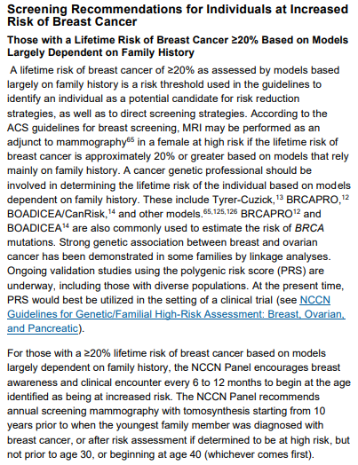

**Exhibit A** (continued)

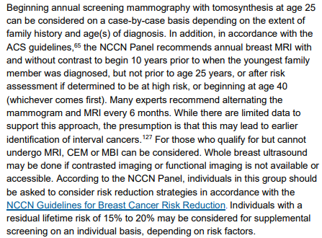

ACS = American Cancer Society

CEM = contrast-enhanced mammography

MBI = molecular breast imaging

Source: https://www.nccn.org/professionals/physician_gls/pdf/breast-screening.pdf#page=3

**Exhibit B**

**American Cancer Society Recommendations for the Early Detection of Breast Cancer**

**Last Revised:**December 19, 2023

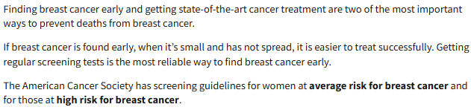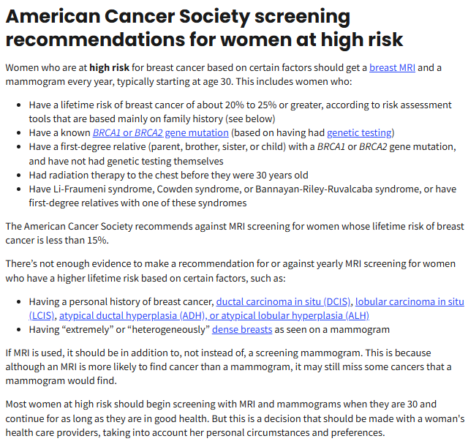

Source: https://www.cancer.org/cancer/types/breast-cancer/screening-tests-and-early-detection/american-cancer-society-recommendations-for-the-early-detection-of-breast-cancer.html

**Exhibit C**

Breast Cancer Screening for Women at Higher-Than-Average Risk: Updated Recommendations FROM the ACR

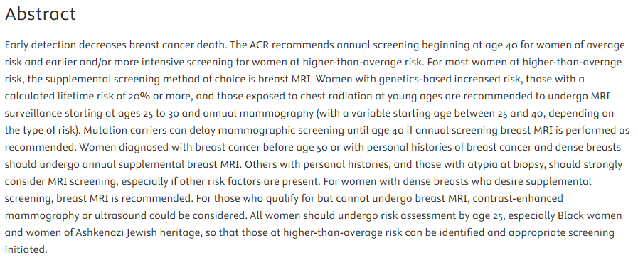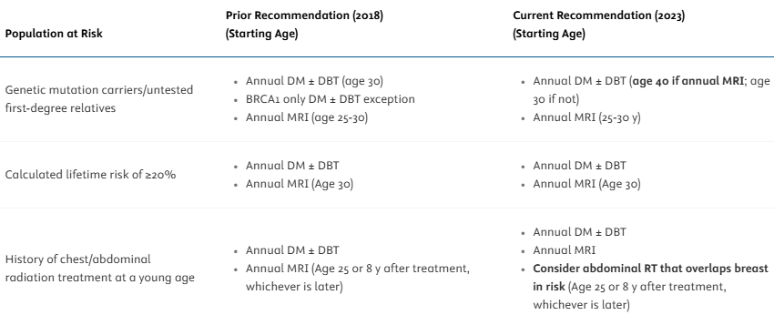

**Exhibit C** (continued)

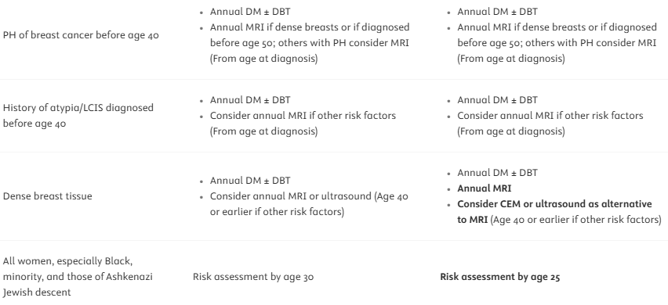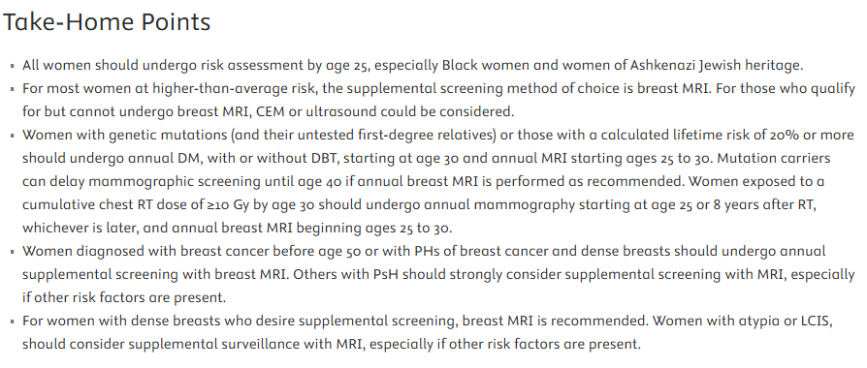

DM = digital mammography

DBT = digital breast tomosynthesis

RT = radiation therapy

PH = personal history

CEM = contrast-enhanced mammography

Source: https://www.jacr.org/article/S1546-1440(23)00334-4/fulltext

**Exhibit D**

Last updated 9/17/2024

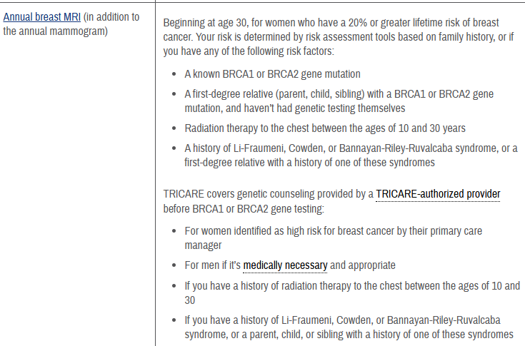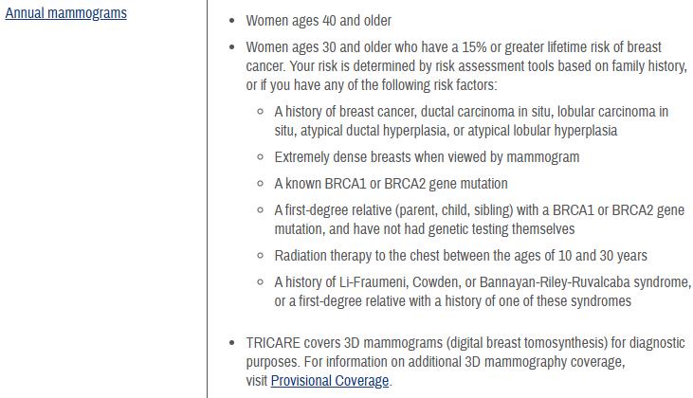

Source: https://tricare.mil/CoveredServices/IsItCovered/BreastExams

1. Prevalence of Americans reporting a family history of cancer indicative of increased cancer risk: estimates from the 2015 National Health Interview Survey

   https://pmc.ncbi.nlm.nih.gov/articles/PMC9162122/#:~:text=According%20to%20the%20United%20States,et%20al.%2C%202016).
2. NCCN Clinical Practice Guidelines in Oncology https://www.nccn.org/professionals/physician_gls/pdf/genetics_bopp.pdf